5.1 – Right Triangle Trigonometry
Objectives:
- Evaluate the six trigonometric functions given different information.
- Solve for missing sides of a triangle using trigonometric functions.
- Solve a triangle given an angle and two sides.
Notes:

Assignment 5.1
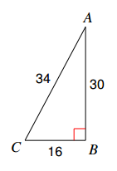
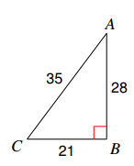
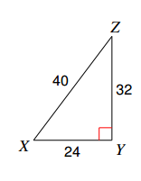
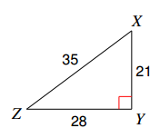
Find the value of each trigonometric ratio.
1. $\tan{Z}$ 2. $\cos{C}$ 3. $\sin{C}$ 4. $\tan{X}$

Find the values of the indicated trigonometric functions for angle $θ.$
5. $\sin{θ} and\tan{θ}$ 6. $\cos{θ} and\cot{θ}$
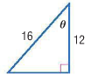
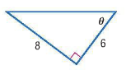

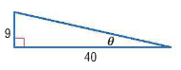
7. $\csc{θ} and\sec{θ}$ 8. $\sin{θ} and\cot{θ}$
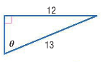

9. $\cos{θ} and\csc{θ}$ 10. $\tan{θ} and\sec{θ}$
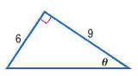
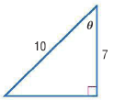

In a right triangle, $∠A and ∠B$ are acute.Find the values of the five remaining trigonometric functions.
11. $\tan{A}=\frac{8}{15}$ 12. $\cos{A}=\frac{3}{10}$

13. $\tan{B}=3$ 14. $\sin{B}=\frac{4}{9}$

Use a trigonometric function to find each value of x. Round to the nearest tenth.
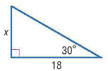
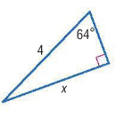
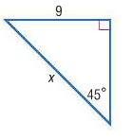
16. 17. 18.

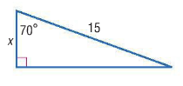
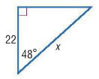
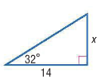
19. 20. 21.

22. Devon wants to build a rope ladder from the ground to his treehouse. At a distance of 20 meters to the left of Devon’s treehouse, an angle of 52° is measured from the ground to the treehouse. Find the length of the rope ladder.
5.2 – Special Right Triangle Ratios
Objectives:
- Solve special right triangles.

Notes:
Assignment 5.2
Find the exact value of each trigonometric function.
1. $\tan{60°}$ 2. $\sin{60°}$ 3. $\cos{45°}$ 4. $\sec{30°}$

5. $\cot{60°}$ 6. $\csc{45°}$ 7. $\cos{30°}$ 8. $\sin{30°}$

Solve for $x$ and $y$ in each triangle.
$$y$$
$$x$$
$$12$$
30$°$
$$y$$
$$x$$
$$16$$
60$°$
9. 10.

$$x$$
$$y$$
$$2\sqrt{2}$$
45$°$
11. 12.
$$\frac{3\sqrt{2}}{2}$$
45$°$
$$x$$
$$y$$

Two bicycle ramps each cover a horizontal distance of 8 feet. One ramp has a 20$°$ angle of elevation, and the other ramp has a 35$°$ angle of elevation, as shown at the right.
35$°$
20$°$
8$ft$
8$ft$
13. How much taller is the second ramp than the first? Round to the nearest tenth.
14. How much longer is the second ramp than the first? Round to the nearest tenth.

A falcon at a height of 200 feet sees two mice at points A and B, as shown in the diagram.
200$ft$
62$°$
10$°$
$$x$$
$$y$$
$$z$$
A
B
15. What is the approximate distance $z$ between the falcon and mouse B?

16. How far apart are the two mice?

17. A boy flying a kite lets out 300 feet of string which makes an angle of $30°$ with the ground. Assuming that the string is straight, how high above the ground is the kite?

18. A ladder leaning against the wall makes an angle of $60°$ with the ground. If the foot of the ladder is 6.5 feet from the wall, how high on the wall is the ladder?

19. An airplane climbs at an angle of 30$°$ with the ground. Find the ground distance it has traveled when it has attained an altitude of 400 feet.

20. A wire attached to the top of a pole reaches a stake in the ground 20 feet from the foot of the pole and makes an angle of 60$°$ with the ground. Find the length of the wire.

21. In a $30°-60°-90°$ triangle, the longer leg has a length of 5. What is the length of the shorter leg?
a. $\frac{5\sqrt{3}}{3}$ b. $\frac{5\sqrt{3}}{2}$ c. $\frac{10\sqrt{3}}{3}$ d. $5\sqrt{3}$

5.3 – Define General Angles and Use Radian Measure
Objectives:
- Students will understand what a radian is and convert between degrees and radians.
- Students will be able to draw angles in standard position.
- Students will understand reference and coterminal angles.
- Students will evaluate trigonometric functions for general angles.
Notes:
Assignment 5.3
Rewrite each degree measure in radians and each radian measure in degrees.
1. 330$°$ 2. $\frac{5π}{6}$ 3. $-\frac{π}{3}$

4. $-50°$ 5. 40$°$ 6. $5π$

Sketch each angle with the given measure in standard position. Find its reference angle.
7. 75$°$ 8. $\frac{3π}{4}$ 9. $-90°$

10. $-\frac{2π}{3}$ 11. 295$°$ 12. $\frac{7π}{3}$

Determine if each pair of angles is coterminal. Justify your answer.
13. 390$°$ and 30$°$ 14. 45$°$ and 415$°$ 15. 60$°$ and -660

16. $\frac{π}{9}$ and 380$°$ 17. 36$°$ and $\frac{8π}{7}$ 18. $\frac{π}{12}$ and 735

Find the exact value of each expression. (Hint: draw the reference triangle)
19. $\sin{150°}$ 20. $\cos{420°}$ 21. $\tan{315°}$

22. $\sin{-225°}$ 23. $\cos{240°}$ 24. $\tan{-300°}$
5.4 – Define General Angles and Use Radian Measure
Objectives:
- Students will evaluate trigonometric functions for general angles.
- Students will be able to connect special right triangles to the unit circle in Q1.
- Students will be able to expand the unit circle to all quadrants.
- Students will understand reference angles.
Notes:

Assignment 5.4
Find the exact value of each expression. (Hint: draw the reference triangle.)
1. $\sin{\frac{7π}{6}}$ 2. $\cos{-\frac{9π}{4}}$ 3. $\tan{\frac{11π}{4}}$

4. $\sin{-\frac{5π}{3}}$ 5. $\cos{-\frac{11π}{6}}$ 6. $\tan{\frac{17π}{3}}$

7. $\sin{180°}$ 8. $\cos{\frac{3π}{2}}$ 9. $\tan{450°}$

The given point is on the terminal side of$θ$ in standard position. Find the measure of$θ$.
10. $\left(1, \sqrt{3}\right)$ 11. $\left(3, -3\right)$ 12. $\left(-\frac{2}{\sqrt{3}}, 2\right)$

The terminal side of $θ$ in standard position contains the given point. Find the exact values of the six trigonometric functions of$θ$.
13. $(-6, 8)$ 14. $(3, 0)$ 15. $(4, -2)$

Suppose $θ$ is an angle in standard position whose terminal side is in the given quadrant. For each function, find the exact values of the remaining five trigonometric functions of $θ$.
16. $\sin{θ=\frac{4}{5}}$; Quadrant II 17. $\cos{θ}=-\frac{8}{17}$; Quadrant III 18. $\tan{θ}=-\frac{2}{3}$; Quadrant IV

5.5 – Inverse Trigonometric Functions
Objectives:
- Students will be able to relate the concept of inverse functions to trigonometric functions
Notes:
Assignment 5.5:
Find the exact value of each angle without using a calculator.

- $\sin^{-1}{\frac{\sqrt{3}}{2}}$
- $\sin^{-1}{-\frac{1}{2}}$

- $\cos^{-1}{\frac{1}{2}}$
- $\tan^{-1}{1}$

- $\tan^{-1}{-1}$
- $\cos^{-1}{0}$

- $\tan^{-1}{0}$
- $\sin^{-1}{1}$

Use a calculator to find the approximate value of each angle. Put your answer in degrees.

- $\sin^{-1}\left(0.362\right)$
- $\sin^{-1}\left(0.67\right)$

- $\tan^{-1}\left(-12.5\right)$
- $\cos^{-1}{(-0.23)}$

Solve each equation without using a calculator.

- $\sin{x}=-\frac{1}{2}$
- $2\cos{x}+\sqrt{3}=0$

- $\tan{x}-\sqrt{3}=0$
- $4\sin{x}+1=3$

Solve each equation. Put your answers in degrees. Round answers to the nearest tenth.

- $5\tan{x}+4=8$
- $4\sin{x}-2=1$

- $3\cos{x}+2=0$

- $\frac{1}{4}\tan{x}=5$

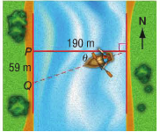
- A boat is traveling west to cross a river that is 190 meters wide. Because of the current, the boat lands at point Q, which is 59 meters from its original destination point P. Write an inverse trigonometric function that can be used to find $θ$, the angle at which the boat veered south of the horizontal line. Then find the measure of the angle to the nearest tenth.

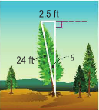
- A 24-foot tree is leaning 2.5 feet left of vertical, as shown in the figure. Write an inverse trigonometric function that can be used to find $θ$, the angle at which the tree is leaning. Then find the measure of the angle to the nearest degree.

The given point is on the terminal side of$θ$ in standard position. Find the measure of$θ$.
- $(2, 5)$ 24. $(-3, 8)$ 25. $(0, -4)$

