Unit 1.1 – Basic Properties of Exponents
Student Learning Targets:
- I can understand the properties of exponents and how to use them.
- I can simplify algebraic terms with common base exponents.

Properties of exponents

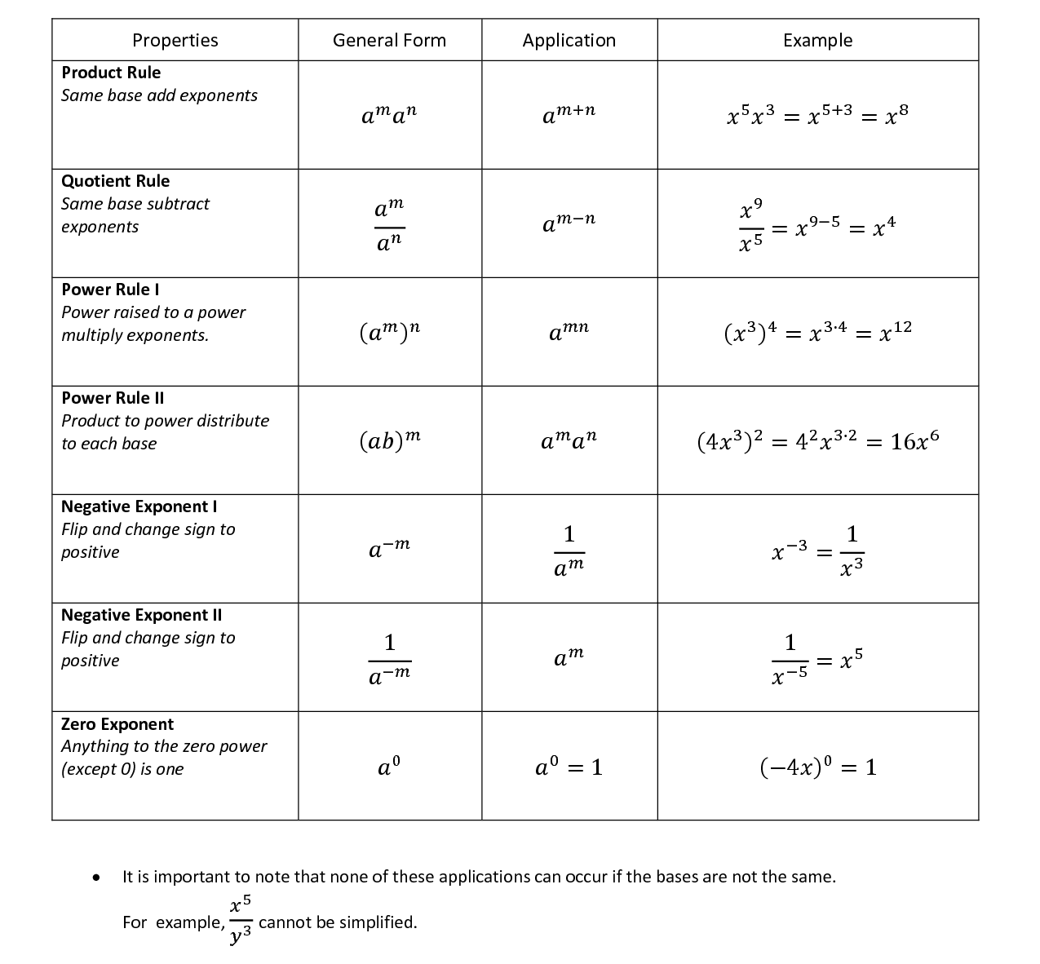
An exponent refers to the number of times a number is multiplied by itself. For example, 2 to the 3rd (written like this: 2³) means: 2 x 2 x 2 = 8

Referring to 2³, 2 is called the Base and 3 is called the exponent.
Notes(1.1):

Assignment 1.1
Evaluate using the properties of exponents.

- $3^{3}∙3^{2}$
- ${\left(4^{-2}\right)}^{3}$

- $\frac{5^{2}}{5^{5}}$
- ${\left(\frac{3}{5}\right)}^{4}$

- $\frac{3^{4}}{3^{-2}}$
- ${\left(\frac{2}{3}\right)}^{-5}{\left(\frac{2}{3}\right)}^{4}$

Simplify the expression.

- ${\left(2^{2}y^{3}\right)}^{5}$
- ${\left(3a^{3}b^{5}\right)}^{-3}$

- $\left(w^{3}x^{-2}\right)\left(w^{6}x^{-1}\right)$
- ${\left(5s^{-2}t^{4}\right)}^{-3}$

- $\frac{w^{-2}}{w^{6}}$
- $\frac{3c^{3}d}{9cd^{-1}}$

- $\frac{x^{2}y^{-3}}{3y^{2}}∙\frac{y^{2}}{x^{-4}}$
- $\frac{x^{-1}y^{2}}{x^{2}y^{-1}}$

Unit 1.2 – Use the Properties of Rational and Irrational Numbers
Student Learning Targets:
- I can simplify radical expressions.
- I can add, subtract, and multiply real numbers
- I can explain why adding and multiplying two rational numbers results in a rational number.
- I can explain why adding a rational number to an irrational number results in an irrational number.
- I can explain why multiplying a nonzero number to an irrational number results in an irrational number.

A rational number can be written as a terminating or repeating decimal. Irrational numbers are non-terminating, non-repeating decimals.

Notes:

Notes (Continued for 1.2):
Assignment 1.2
Simplify each radical expression.

- $\sqrt{125}$
- $\sqrt{50}$

- $\sqrt{200}$
- $\sqrt[3]{-162x^{2}y^{3}}$

- $\sqrt{108x^{3}y}$
- $\sqrt[3]{27x^{5}y^{7}}$

Find each sum or difference.

- $2\sqrt{5}-5\sqrt{3}-2\sqrt{3}$
- $-3\sqrt[4]{3}+3\sqrt{3}+2\sqrt{3}$

- $4\sqrt[4]{10}-\sqrt[4]{10}-2\sqrt[4]{10}$
- $6\sqrt{3}-7\sqrt[3]{5}+2\sqrt[3]{5}-2\sqrt{3}$

- $3\sqrt{8}+4\sqrt{16}-\sqrt{2}+5$
- $6\sqrt{9}+2\sqrt{20}-3\sqrt{5}-\sqrt{25}$

Assignment 1.2 (Continued)
Find each product. Simplify each expression fully.

- $\sqrt{10}\left(\sqrt{6}+\sqrt{10}\right)$
- $\sqrt{3}\left(4\sqrt{6}+5\right)$

- $\sqrt{5}\left(3\sqrt{10}+4\right)$
- $\sqrt{6}\left(2+3\sqrt{2}\right)$

- $(-2\sqrt[4]{3}+5)(4\sqrt[4]{3}+4)$
- $\left(1+\sqrt{2}\right)\left(-3-2\sqrt{2}\right)$

- $\left(\sqrt[3]{2}+\sqrt[3]{5}\right)\left(\sqrt[3]{2}-\sqrt[3]{5}\right)$
- $(\sqrt{2}+3\sqrt{5})(\sqrt{2}-3\sqrt{5})$

Additional Problems: UM2: Page 248 #17-34; Page 254 #1-25
MA2: Page 424 #32-40, 52-55

Unit 1.3 – Extend the Properties of Exponents to Rational Exponents
Student Learning Targets:
- I can convert radical notation to rational exponent notation, and vice-versa.
- I can extend the properties of integer exponents to rational exponents and use them to simplify expressions.

$$Let a^{1/n} be the nth root of a, and let m be a positive integer, then {\left(\sqrt[n]{a}\right)}^{m}={\left(a^{1/n}\right)}^{m}=a^{m/n}$$

Notes:

Notes (continued for 1.3):
Assignment 1.3
Write each expression in radical form.

- $8^{3/5}$
- ${19}^{7/2}$
- $x^{1/4}$

Write each expression in exponential form.

- ${\left(\sqrt[3]{4}\right)}^{5}$
- ${\left(\sqrt[7]{w}\right)}^{6}$
- $\sqrt{5}$

Simplify each expression using the properties of rational exponents.

- $7^{1/4}*7^{1/2}$
- ${(6^{1/2}*4^{1/4})}^{2}$
- ${\left(4^{5}*3^{5}\right)}^{{-1}/5}$

- $\frac{5}{\sqrt[4]{5}}$
- ${\left(\frac{{42}^{1/3}}{6^{1/3}}\right)}^{2}$

- ${\left(125x^{-6}\right)}^{1/3}$

- ${\left(\frac{2x^{5}}{{32x}^{25}}\right)}^{3/4}$
- $\frac{x^{3/2}y^{{-9}/2}}{x^{5/2}y^{7/2}x^{{-7}/2}}$
- ${(\sqrt[5]{2x^{4}y^{3}})}^{-10}$

- ${\left(\frac{a^{{-3}/2}b^{3/2}a^{1/2}b^{2}}{a^{1/3}b^{1/2}}\right)}^{4}$
- ${\left(\sqrt[4]{w^{7/4}y^{16}r^{12}w^{-3/4}}\right)}^{2}$
- ${\left(a^{3/2}b^{5/3}\right)}^{6}{\left(ba^{7/9}\right)}^{18}$

Additional Problems: MA2: Page 417 #7-14, 21-32; Page 425 #3-22
Unit 1.4 – Perform Arithmetic Operations with Complex Numbers
Student Learning Targets:
- I can understand that the set of complex numbers includes the set of all real numbers and the set of imaginary numbers.
- I can express numbers in the form a + bi.
- I can add, subtract, and multiply complex numbers.

A complex number is any number in the form a + bi. The imaginary unit i is defined as $i=\sqrt{-1}$. We commonly use the fact i² = –1 to help us in simplifying expressions.

Notes:

Notes (Continued for 1.4):
Assignment 1.4
Simplify.

- $\sqrt{-121}$
- $\sqrt{-169}$

- $\sqrt{-32}$
- $\sqrt{-162}$

Write the expression as a complex number in standard form.

- $\sqrt{-81}+\sqrt{16}$
- $\sqrt{-144}+\sqrt{121}$

- $\sqrt{-180}+\sqrt{98}$
- $\sqrt{-75}+\sqrt{288}$

Write the expression as a complex number in standard form.

- $\left(6-3i\right)+\left(5+4i\right)$
- $\left(-1+4i\right)+\left(-9-2i\right)$

- $\left(-14i-3\right)+\left(-7i+6\right)$
- $\left(4i-10\right)+\left(7-8i\right)$

- $\left(-2-6i\right)-\left(4-6i\right)$
- $\left(-1+i\right)-\left(7-5i\right)$

Assignment 1.4 (Continued)

- $\left(6i+4\right)-\left(10i+8\right)$
- $\left(3i-8\right)-\left(11+7i\right)$

- $6i(3+2i)$
- $-2i(-7i+14)$

- $i\left(4-10i\right)$
- $\left(8-3i\right)\left(2+4i\right)$

- $\left(3+2i\right)\left(-2-3i\right)$
- $\left(-2-i\right)\left(11+6i\right)$

- $\left(2+2i\right)\left(2-2i\right)$
- $\left(-5-3i\right)\left(-5+3i\right)$

