Unit 4.1 – Sample Spaces, Venn Diagrams, and Two-Way Tables
Student Learning Targets:
- I can identify an event as a subset of a set of outcomes (a sample space).
- I can draw Venn diagrams that show relationships (unions, intersections, or complements) between sets within a sample space.
You have the choice of white milk or chocolate milk for lunch. You can also choose a chocolate chip cookie or an oatmeal cookie. How many choices do you have? Create a tree diagram.
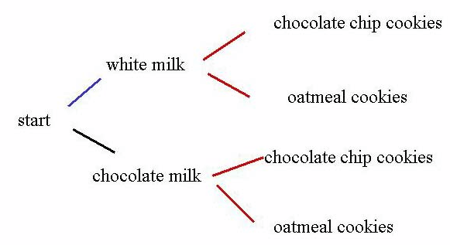
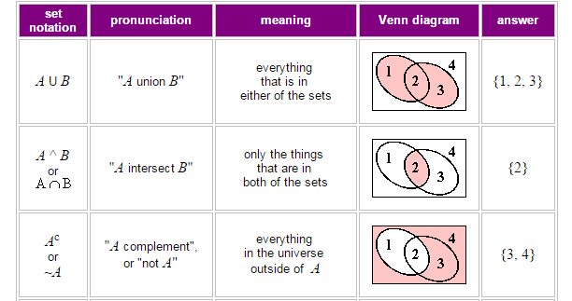

Assignment 4.1
Represent the sample space for each experiment by making an organized list. Make use of a table or tree diagram if necessary.

- The meetings for a club can be held on Monday or Tuesday at either 7:00pm or 8:00pm.

- You roll a single six-sided die and then flip a coin.

- You flip three fair coins.

- You have the choice of turkey, ham or beef sandwich on rye, wheat, or white bread. You may also choose mustard or mayo.

Create a Venn diagram to represent the set described.
- Of the set of numbers less than or equal to 11, set A contains the factors of 10 and set B contains odds.

- $A∪B=\{$
$A∩B=\{$
- In a deck of cards, set A contains the face cards and set B contains the black cards.

- $A∪B=\{$
$A∩B=\{$
Create a Venn diagram to represent the data described. Then use the Venn diagram to answer the questions.
- From a survey taken, 23 students have only one brother, 17 students have only one sister, 19 students have both one brother and one sister, and 8 students are the only child. Label your Venn diagram with the set names BROTHER and SISTER.

- $A∪B=\{$
$A∩B=\{$
- How many students have one brother?

- How many students have one sister?

- How many students total were given the survey?

Create a Venn diagram to represent the data described. Then use the Venn diagram to answer the questions.
- In the college math department, there are 225 male students of which 175 are full-time. There are 200 female students, 75 which are part-time. Label your Venn diagram with the set names MALE and PART TIME.

- $A∪B=\{$
$A∩B=\{$
- How many part-time students are there total?

- How many full time students are there total?

- Using the Venn diagram from question 14, create a two-way table to represent the data.

Create a Venn diagram and two-way table to represent the following data.
- In a high school of 320 students, 85 take band, 200 play sports and 60 play both sports and take band. How many students did not take band or play a sport?

Complete the two-way table and then create a Venn diagram from the two-way table and then answer the questions using the data.
Activity | Jog | Picnic | Total
Male |  | 10
Female | 11
Total |  | 25 | 50

- How many males were given the survey?
- How many people prefer to jog over having a picnic?
- 30 people were given the survey: “Do you play soccer?” and “Do you play lacrosse?” 14 people played soccer and 19 people played lacrosse. 10 people said that they played both soccer and lacrosse. Create a Venn diagram.

- $∪B=\{$
- $A∩B=\{$
Unit 4.2 – Fundamental Counting Principle, Permutations, and Combinations
Student Learning Targets:
- I can define n! as the product: $n∙\left(n-1\right)∙…∙3∙2∙1$.
- I can understand that a permutation is a rearrangement of elements in an ordered list.
- I can understand that combination is the number of ways to choose r items from n elements.

$$Permutation:{}_{n}P_{r}=\frac{n!}{\left(n-r\right)!}$$ | $$Combination:{}_{n}C_{r}=\frac{n!}{r!\left(n-r\right)!}$$ | $$Repetition: \frac{n!}{s_{1}!s_{2}!…s_{k}!}$$

Notes (Continued for 4.2)
Assignment 4.2

Evaluate the expression.

- $7!$
- $11!$

- $6!∙5!$
- $\frac{8!}{3!5!}$

Evaluate each permutation or combination.

- ${}_{10}P_{4}$
- ${}_{25}P_{3}$

- ${}_{19}C_{14}$
- ${}_{21}C_{4}$

Find the number of distinguishable permutations of the letters in the word.

- CLEVELAND
- HONOLULU

Find the number of possible outcomes for each situation presented.
- At a local pizza joint, they have the following options for a custom pizza:
Crust: Thin, Deep Dish, Cheese Crust
Meat: Pepperoni, Sausage, Hamburger, Ham, Bacon
Vegetables: Mushrooms, Olives, Onions, Jalapenos, Peppers
- How many outcomes are available if you choose one from each category?
- How many outcomes are available if you want two types of meats?

- How many different license plates are possible if (a) digits and letter can be repeated, and (b) digits and letters cannot be repeated if the configuration is 3 letters, 2 digits, 2 letters?

- A photographer lines up 12 people for a photo in a single file line. How many different ways could that group be lined up for the picture?
Assignment 4.2 (Continued)

- In a race of 16 people, the top 8 are awarded different amounts of prize money, with first receiving the most, second receiving the next most and so on. How many different ways can those top 8 runners finish?

- In a race of 16 people, the top 8 are awarded the same amount of prize money. How many different ways can those top 8 runners finish?

- In a standard deck of cards, if the order in which cards are dealt is not important:
- How many ways can you be dealt a 5 card hand?
- How many hands have 5 face cards?
- How many hands have 2 kings, 2 queens, and one other card?

- A music store has a display of 8 instruments, where 3 identical keyboards, 2 identical guitars, and 3 identical violins are shown. How many different ways can they be displayed?

- To keep computer files secure, you create a 6 character password, using letters and/or numbers. How many passwords are there if the characters can be repeated? Cannot be repeated? Which type of password is more secure? Explain.

Additional Problems: UM2: Page 81 Problems 15-18,23-27, 28-33
MA2: Page 349 Problems 3-46

Unit 4.3 – Independent/Dependent Events & Conditional Probability
Student Learning Targets:
- I can use appropriate notation for individual events as well as their intersection.
- I can understand that independent events satisfy the relationship $P\left(A\right)∙P\left(B\right)=P\left(A∩B\right).$
- I can understand conditional probability and how it applies to real-life events.
- I can define the probability of event (A and B) as the probability of the intersection of A and B.
- I can understand P(B|A) to mean the probability of event B occurring when A has already occurred.

Independent Events  $$P\left(A and B\right)=P(A)∙P(B)$$  $$P\left(A ∩ B\right)=P(A)∙P(B)$$ | Dependent Events  $$P\left(A and B\right)=P(A)∙P(B|A)$$  $$P\left(A ∩ B\right)=P(A)∙P(B|A)$$ | Conditional Probability  $$P\left(A|B\right)=\frac{P(A∩B)}{P(B)}$$

Notes (Continued for 4.3)
Assignment 4.3

Events A and B are independent. Find the indicated probability.

- $P\left(A\right)=0.4$
$P\left(B\right)=0.6$
$P\left(A∩B\right)= __?__$
- $P\left(A\right)=0.25$
$P\left(B\right)= __?__$
$P\left(A∩B\right)= 0.2$

- $P\left(A\right)=__?__$
$P\left(B\right)=0.9$
$P\left(A∩B\right)= 0.45$
- $P\left(A\right)=0.675$
$P\left(B\right)=0.235$
$P\left(A∩B\right)= __?__$

Events A and B are dependent. Find the indicated probability.

- $P\left(A\right)=0.3$
$P\left(B|A\right)=0.6$
$P\left(A∩B\right)= __?__$
- $P\left(A\right)=0.8$
$P\left(B|A\right)=__?__$
$P\left(A∩B\right)= 0.32$

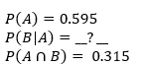

- $P\left(A\right)=__?__$
$P\left(B|A\right)=0.4$
$P\left(A∩B\right)= 0.2$
- $P\left(A\right)=0.595$
$P\left(B|A\right)=0.315$
$P\left(A∩B\right)= __?__$

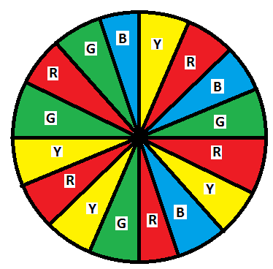
You are playing a game than involved spinning the wheel shown. Find the probability of spinning the given colors.

- Green, then blue
- Red, then yellow
- Blue, then green, then red
- Green, then red, then yellow, then yellow

You are rolling a pair of dice. Find the probabilities that:
- Roll a sum is greater than 7.
- Roll a sum that is odd.
- Roll a sum that is greater than 7 if you know the sum will be odd.

Assignment 4.3 (Continued)

The table shows the status of 200 registered college students. Find:
 | Part Time | Full Time | Total
Female | 80 | 40 | 120
Male | 60 | 20 | 80
Total | 140 | 60 | 200

- Probability a student is female.

- Probability a student is female and a part time student.

- Probability given that a student is female, she is a part time student.

- Probability given that a student is a full time student, they are a male.
For questions 20-23, find the probability of drawing the given cards from a standard deck of 52 cards (a) with replacement and (b) without replacement.
- A club, then a spade.

- A face card, then a 6.

- A 10, then a 2, then a jack.

- A spade, then a red card, then another spade.

- A study shows that 86% of adults wear their seat belts while driving. For teenagers in the same car, if the adult is wearing their seatbelt, the teens wear their belt 83% of the time and 52% of the time if the adult is not wearing their belt. What is the probability that a teenager in the study wears a seat belt?

Additional Problems: UM2: Page 919 Problems 1-27
MA2: Page 721 Problems 3-40

Unit 4.4 – Mutually Exclusive Events
Student Learning Targets:
- I can define the probability of events (A or B) as the probability of their union.
- I can understand and use the formula $P\left(A or B\right)=P\left(A\right)+P\left(B\right)-P\left(A and B\right).$

Two events are considered mutually exclusive if the two events cannot occur at the same time.

Mutually Exclusive Events Non-Mutually Exclusive Events
$P\left(A or B\right)=P\left(A\right)+P\left(B\right)$ $P\left(A or B\right)=P\left(A\right)+P\left(B\right)-P(A and B)$
$P\left(A ∪ B\right)=P\left(A\right)+P\left(B\right)$ $P\left(A ∪ B\right)=P\left(A\right)+P\left(B\right)-P(A ∩ B)$

Notes (Continued for 4.4)
Assignment 4.4

Events A and B are mutually exclusive. Find the indicated probability.

- $P\left(A\right)=0.3$
$P\left(B\right)=0.1$
$P\left(A∪B\right)= __?__$
- $P\left(A\right)=0.55$
$P\left(B\right)= __?__$
$P\left(A∪B\right)= 0.75$

- $P\left(A\right)=__?__$
$P\left(B\right)=0.6$
$P\left(A∪B\right)= 0.92$
- $P\left(A\right)=0.675$
$P\left(B\right)=0.235$
$P\left(A∪B\right)= __?__$

Events A and B are not mutually exclusive. Find the indicated probability.

- $P\left(A\right)=0.5$
$P\left(B\right)=0.35$
$P\left(A∩B\right)= 0.2$
$P\left(A∪B\right)=__?__$

- $P\left(A\right)=0.28$
$P\left(B\right)=0.64$
$P\left(A∩B\right)=__?__$
$P\left(A∪B\right)=0.71$

- $P\left(A\right)=0.46$
$P\left(B\right)=0.37$
$P\left(A∩B\right)=__?__$
$P\left(A∪B\right)=0.31$

- $P\left(A\right)=\frac{2}{7}$
$P\left(B\right)=\frac{4}{7}$
$P\left(A∩B\right)= \frac{1}{7}$
$P\left(A∪B\right)=__?__$

Assignment 4.4 (Continued)

Determine whether the events are mutually exclusive or not mutually exclusive. Then find the probability.

- Drawing a card from a standard deck and getting a jack or a 6.

- Drawing a card from a standard deck and getting a jack or a club.

- Selecting an integer from 1 to 20 and getting an even number or a multiple of 3.

- Selecting an integer from 1 to 20 and getting a prime number or a number less than 7.

- Rolling a die and getting an even or a 3.

- Rolling a pair of two six-sided dice and getting a sum of 3 or 4.

- You and your friend are among several candidates running for class president. You estimate that there is a 45% chance you will win and a 25% chance your best friend will win. What is the probability that you or your best friend win the election?

- You are performing an experiment to determine how well plants grow under different light sources. Out of the 30 plants in the experiment, 12 receive visible light, 15 receive ultraviolet light, and 6 receive both visible and ultraviolet light. What is the probability that a plant in the experiment receives either visible or ultraviolet light?

- On a weekend survey at a popular hiking area, it is found that the probability of a random hiker choosing Trail A is 21% while the probability of choosing Trail B is 53%. The survey discovered that the probability of Trail A or Trail B being hiked is 44%. What is the probability that a hiker chooses both trailed to hike?

- On a farm, 40% of the tomatoes are partially rotten, 30% of tomatoes have been fed on by insects, and 12% are partially rotten and have been fed on by insects. What is the probability that a randomly selected tomato is partially rotten or has been fed on by insects?

Additional Problems: MA2: Page 710 UM2: Page 929

